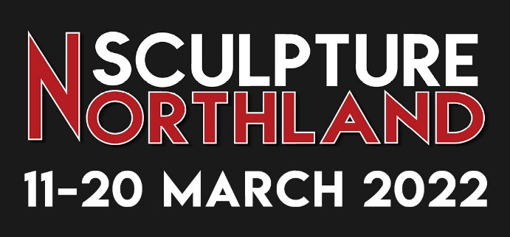

Artist’s Application to Exhibit
Closing date for applications – 24th August 2021

Either save this form as WORD document, fill in your details, then email as an attachment to: events@whangareigardens.org.nz OR print and post to Sculpture Northland, PO Box 1612, Whangarei 0110. You are welcome to pop in to the Gardens to drop it off midweek from Tuesday - Friday. Application forms can also be found on our website https://www.whangareigardens.org.nz/events. Please share.
Name:

Address:

Email:

Phone: Mobile Phone:

I would like the following artwork(s) to be included in Sculpture Northland 2022 Exhibition:
Note: Maximum of 3 artworks, all of which must be suitable for outdoor installation.

Description of Work | Materials | Approx Dimensions | How will the work be installed?

* I enclose / attach sketches/photos of my proposed artworks.
* This will be my first Whangarei Quarry Gardens exhibition, so I enclose / attach my personal artist profile.
(NB Returning exhibitors please supply an updated profile by 13.10.2021)
* I accept the following 3 Conditions of Participation:
(Artist to sign here)

- The organisers will receive commission at 30% of sales price on all exhibition sales, on orders placed during the exhibition, and on exhibited work sold within three weeks of the end of the exhibition.
- I will install my artwork(s) at the site(s) and at the time allocated to me, with minimal disturbance to the Quarry Gardens and in a manner that the artwork(s) will not endanger the safety of the public during the exhibition. After 6pm on Sunday 22nd November, I will remove my unsold artwork(s) and restore the site(s) as needed.
- I will be responsible for all insurance of my artwork(s) while they are at the exhibition location. WQGT will provide overnight security, and have “Guardians” on site during the day over-seeing works.

Note : To ensure the art exhibited is of a high standard, there will be a selection process. Artists will be advised by 14th September of their acceptance (or not). Appointments will then be made to meet Curator, Dorothy McHattie at Quarry Gardens, between 13th – 15th October to choose exhibition site(s) for their artwork(s). Invitations to choose sites will be issued in the order these Application to Exhibit Forms are received.

Event Manager Contact: Kerry Marinkovich email events@whangareigardens.org.nz or phone 021 070 4324
Event Organisers: Whangarei Quarry Gardens Events Committee, PO Box 1612, Whangarei 0110
Our Events Committee is made up of 12 volunteers who work hard to bring this wonderful event to Northland.

